Nur Hafizah Bt Ahmad Fadlullah Suhaimi

No 29 Jalan1/27d, Seksyen 6,

Wnagsa Maju,

53300, Kuala Lumpur

012-2581056

[nurhafizah_ahmadfs@yahoo.com](mailto:nurhafizah_ahmadfs@yahoo.com)

18th February 2014

Asia Recruit

No 3B, 2nd floor,

Jalan Kenari 4,

Bandar Puchong Jaya,

47100 Puchong, Selangor

Dear Sir/Madam

**Re: Job Application related to Human Resource, Marketing and Public Relation positions.**

I am writing you this letter regarding the above mentioned vacant position that I am looking for. Hence, I would like to express my interest for that related positions as it is related with my field of study. I am freshly graduated from International Islamic University Malaysia, Bachelor of Human Sciences majoring in Sociology and Anthropology. I believe that my strong experiences and education will make a very competitive candidate in any company.

Based on my experience, I know how to handle and deal with customers effectively and efficiently while making sure that their needs are taken care of without exception. Hence I would like to request an opportunity for an interview to show you more how I can be a valuable asset for the company.

I have attached my curriculum Vitae which contain my additional information on my experiences and skills for your review in regards to the job opportunity. I would really appreciate if you can consider me for one of these positions and I look forward to discussing this opportunity in person at your earliest convenience.

Thank you for your time and consideration.

Sincerely,

Nur Hafizah Bt Ahmad Fadlullah Suhaimi

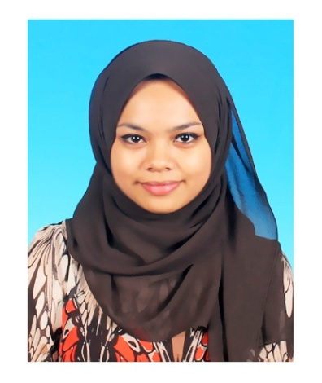

**CURRICULUM VITAE**

**Personal Particulars:**

Name : Nur Hafizah bt Ahmad Fadlullah Suhaimi Permanent Address : No. 29, Jalan 1/27D Seksyen 6, Wangsa Maju,

53300 Kuala Lumpur

Mobile no. : 012-2581056

E-Mail : Nurhafizah_ahmadfs@yahoo.com

Citizen : Malaysian

I.C. No : 901130-14-6760

Age : 24 years old

**Objective:**

I am seeking for a rewarding and challenging position within the fields of human resource, sales and marketing and management with the possibility to learn new skills and knowledge as well as to exploit my own while being able to contribute positively to the company.

**Education Background:**

**2009 – 2014**

* International Islamic University of Malaysia Gombak, Selangor.
* Bachelor in Human Sciences (Sociology & Anthropology)
* CGPA : 2.93 (2nd class upper)

**2008 - 2009**

* Centre for Foundation Studies, International Islamic University Malaysia

**Co-curricular Involvements:**

* Representative of IIUM for MOE Entrepreneurial Awards 2013 organized by National Entrepreneurship Council Higher Education (NECHE).
* Participate in “Lab Minda Keusahawanan” program organized by Entrepreneurship Development Centre in 2013 and were invited to give a talk regarding my experience in business to IIUM students in that program.
* Participate in choir competition “Peringkat Wilayah Persektuan Kuala Lumpur” organized by Jabatan Perpaduan Negara dan Integrasi Nasional Wilayah Persekutuan Kuala Lumpur.
* Participant of camping program organized by Quranic Youth Club,IIUM
* Participate in Hiking to Broga Hill program organized by Quranic Youth Club,IIUM
* Participate in a social work activity ‘feed the homeless’ organized by SOCASA.

**LANGUAGE PROFICIENCY**

|  |  |  |  |
| --- | --- | --- | --- |
| **Language** | **Reading** | **Spoken** | **Written** |
| Malay | Excellent | Excellent | Excellent |
| English | Excellent | Good | Good |
| Arabic | Average | Average | Average |

**WORKING EXPERIENCE:**

**2012**

* **JABATAN PERPADUAN (Internship)**

Duration : 3 Months

**2011**

* **SOCIAL CLINIC**

Position : officer

Duration : 2 weeks

* **AZMIE TSHIRT**

Position : Marketing

Duration : 5 Months

**2009 – 2010**

* **OREN SPORT, CHERAS**

Position : Marketing

Duration : 3 Months

* **SCICOM**

Position : Admin ,data entry

Duration : 1 Month

**2008**

* **Principle, Parkson KLCC**

Position : Promoter

Duration : 3months

**Additional Information:**

* Familiar with internet applications and Microsoft Office (Word, Excel and Power Point).
* Willing to learn and easy adapting to new environment.
* Ready to serve long hours of work.
* A dynamic team player, yet able to work independently and under pressure.
* Run my own business since 2011.

**Refrences**

* Available upon request